**Project Documentation**

**Sphere Coding Club — Diwali Team Project 2025**

**Project Title:** **Build a Mini Website**

**Group Number: 1**

**Team Members:**

* **Shreyash Atre** — Structure, Linking & Documentation
* **Mihir Mendake** — Styling & Layout Design
* **Bhagyashri lokhande**

**Submission Date: 24th October 2025**

**Submitted To: Sphere Coding Club**

**Project Type: HTML & CSS Website**

**1. Introduction**

This project is a simple yet creative two-page website designed using **HTML** and **CSS**.  
The website introduces our team members and presents an overview of our Hackathon Club, including its purpose, activities, and goals.

The goal of this project was to learn the basics of web development — understanding page structure, linking multiple pages, and styling layouts using CSS.  
It also helped us collaborate as a team and divide tasks efficiently.

**2. Objectives**

The main objectives of this project were:

* To understand and implement the **basic structure of a website** using HTML.
* To apply **CSS styling techniques** for better visual design and layout.
* To learn **effective team coordination** and task distribution during project development.
* To gain confidence in **creating, organizing, and hosting** a small-scale website.
* To represent our **Sphere Coding Club** professionally through a live web platform.

**3. Tools and Technologies Used**

| **Tool / Technology** | **Purpose** |
| --- | --- |
| **HTML5** | To create and structure web pages. |
| **CSS3** | To style the pages, manage layout, and add visual elements. |
| **VS Code** | As the main development environment for coding. |
| **GitHub Pages** | For hosting and live preview of the project. |

**4. Project Overview**

**The website consists of three main pages, plus navigation and contact footer:**

**Page 1 — Home / Sphere Coding Club**

* Introduces the club and its vision.
* Explains hackathons, their benefits, and the club’s role in promoting them.
* Shows a brief mission statement and activities.
* Features clickable navigation links: Home, Contact Us, Projects, About Us, Member’s Profile.
* Footer includes location, contact number, email, and copyright info.

**Page 2 — About Us**

* Displays the complete team with profile pictures, names, and skills.
* Includes both core team members and additional student members.
* Designed with a modern, centered layout using consistent colors and fonts.

**Page 3 — Vision & Achievements**

* Lists the club’s vision points (innovation, learning, mentorship, hackathon participation).
* Highlights key achievements: coding competitions, workshops, collaborations, projects, hackathon success, mentorship, internship support.
* Maintains visual consistency and clear navigation to return to Home.

**Navigation: All pages are linked via a top navigation bar and “Back to Home” buttons.  
Live Website: [https://shreyash0216.github.io/sphere-coding-club/](https://shreyash0216.github.io/sphere-coding-club/?utm_source=chatgpt.com" \t "_new)**

**5. Daily Progress Summary**

| **Date** | **Task Completed** | **Member(s) Involved** |
| --- | --- | --- |
| **18 Oct** | Discussed project idea and divided roles | Mihir & Shreyash |
| **19 Oct** | Created basic HTML structure for Page 1 | Mihir |
| **20 Oct** | Added CSS styling (colors, layout, typography) to Page 1 | Mihir |
| **21 Oct** | Created Page 2 and styled it | Shreyash |
| **22 Oct** | Linked both pages and added navigation bar | Shreyash |
| **23 Oct** | Final styling, testing, and debugging | Mihir & Shreyash |
| **24 Oct** | Documentation and submission preparation | Mihir & Shreyash |

**6. Screenshots**

**Page 1 — Home / Sphere Coding Club**

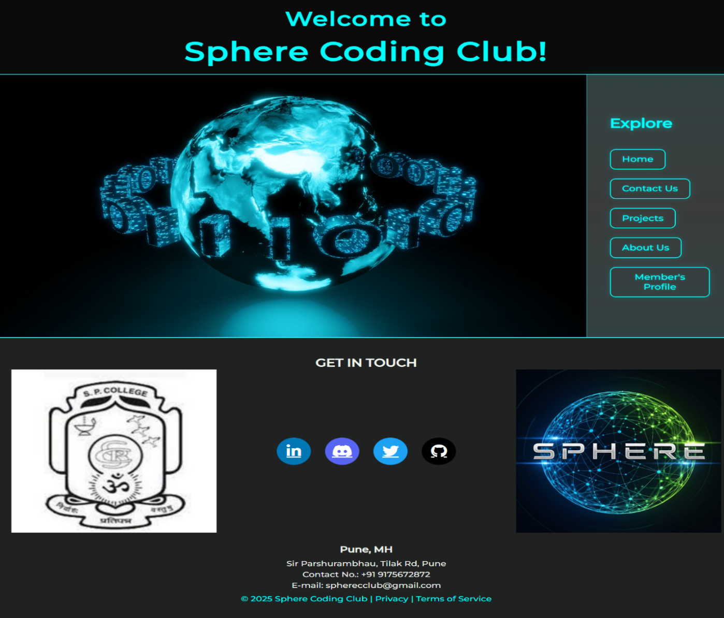

**Page 2 — About Us**

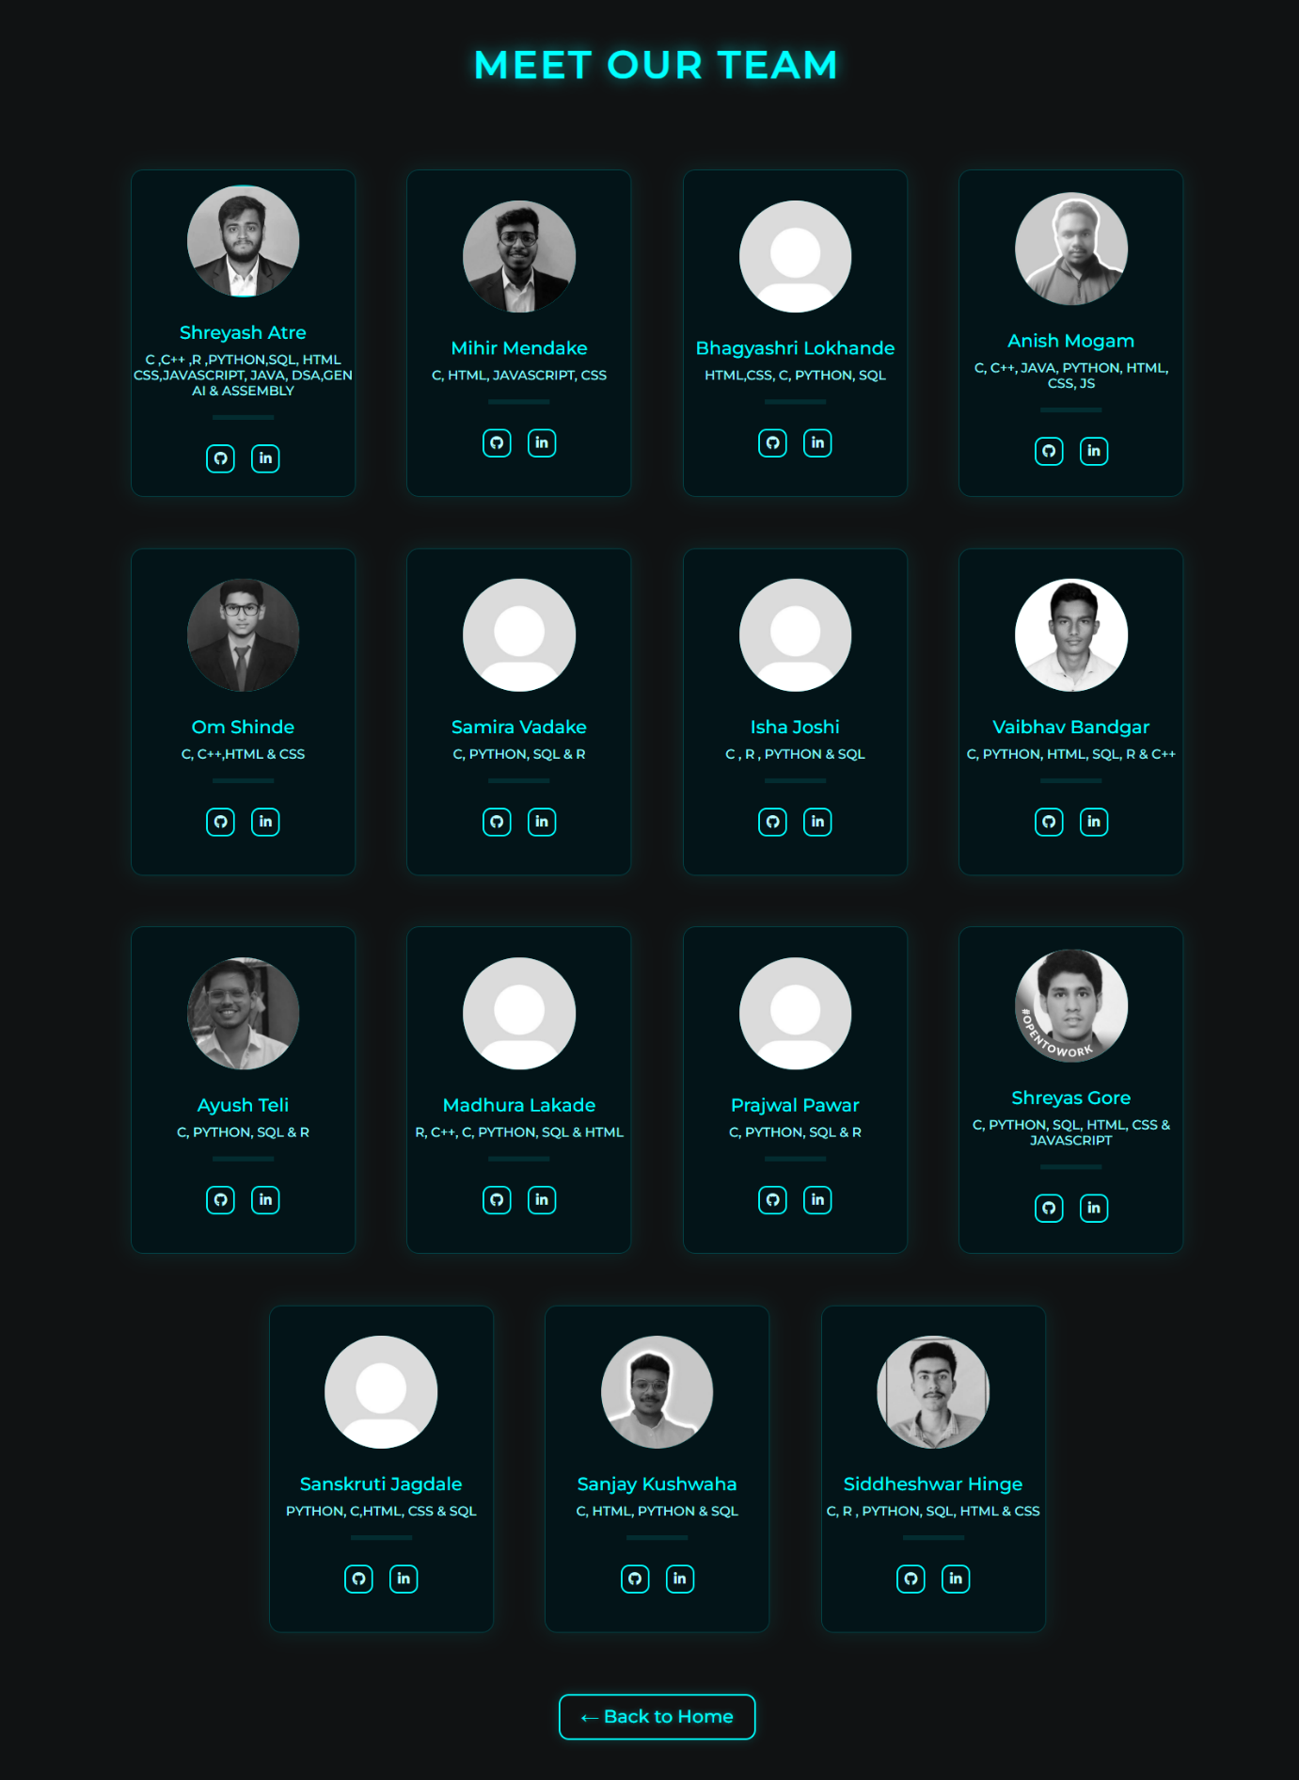

**Page 3 — Vision & Achievements**

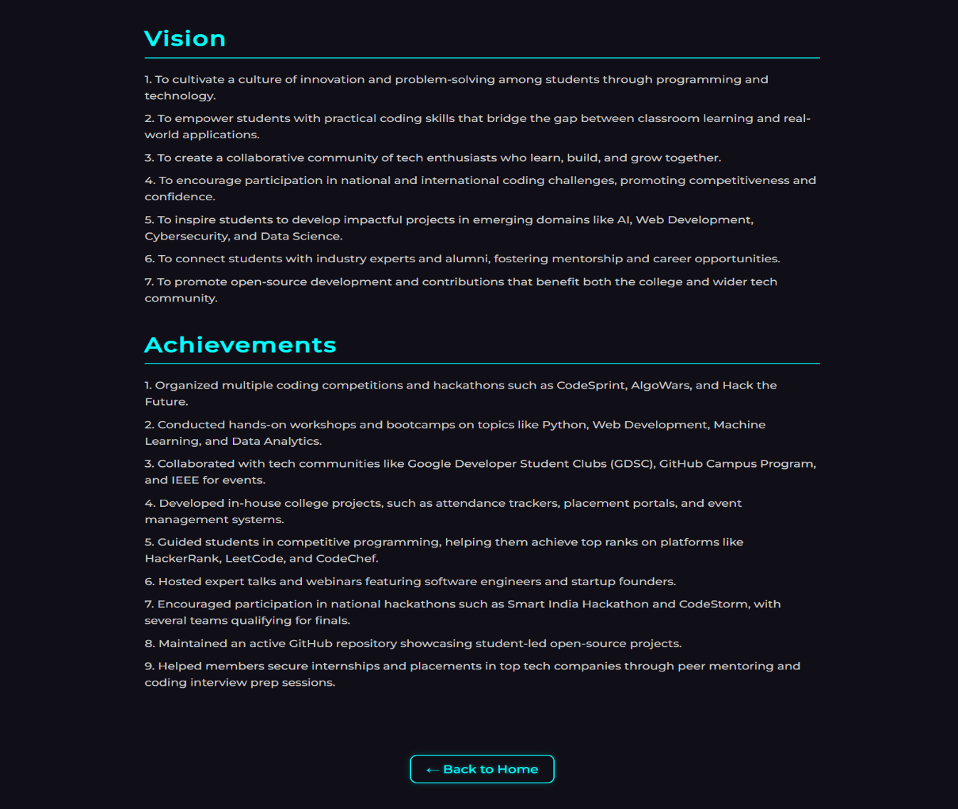

**7. Learnings and Challenges**

**Learnings:**

* Gained hands-on experience in writing HTML and CSS.
* Learned how to link pages and organize project structure.
* Improved our understanding of layout alignment and spacing.
* Developed teamwork and communication skills.

**Challenges:**

* Initially faced alignment and image scaling issues.
* Had to maintain design consistency between both pages.
* Learned to debug HTML structure and CSS rules manually.

**8. Conclusion**

Through this project, we successfully built a functional and visually appealing mini website using HTML and CSS.  
It not only helped us understand the fundamentals of front-end web development but also strengthened our collaboration and creativity as a team.

This experience will serve as a strong foundation for future web development and hackathon projects under Sphere Coding Club. 🚀

**9. References**

* [W3Schools — HTML & CSS Tutorials](https://www.w3schools.com/)
* [MDN Web Docs — HTML Reference](https://developer.mozilla.org/en-US/docs/Web/HTML)
* [CSS Tricks](https://css-tricks.com/)
* **Final Note**

All tasks were equally divided among members, and everyone actively contributed to the project’s success.  
 We thank Sphere Coding Club for this opportunity to learn and grow. 💻✨

**— Group 1 (Mihir | Shreyash | Bhagyashri)**  
 **Sphere Coding Club | October 2025**